**Machine Learning: Recommendation System for Diagnosis of mental health issues**

**Problem Statement:**

The aim of this systems is to recommend social media posts that are free from mental health disorders. This project is based on the sentiment analysis of social media posts that will work in this way if a image or text is free of negative emotions/sentiment then it will be recommended to end user of system. In this project, will scrape posts from different social media platforms like Instagram, Facebook, Twitter and Reddit. Our final product will be a web application which looks like this

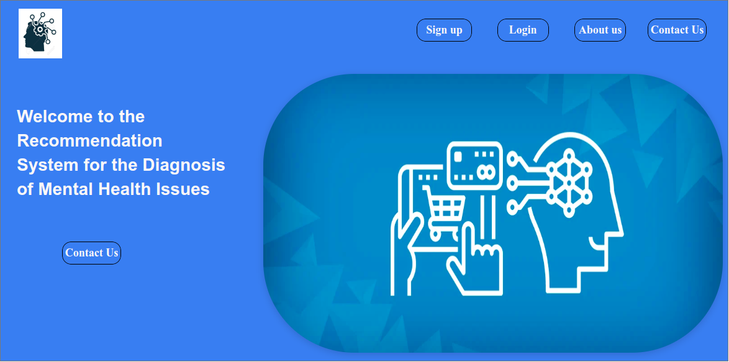

**Approaches:**

I and my team divided this system/project into two phases:

* Data Engineering and ML
* Deployment and MLOps (for Maintenance, Monitoring etc)